Submission link: <https://artcenter.instructure.com/courses/11977/assignments/50738>

**10/15:** Most of my process/behind-the-scenes work is captured in a Figma Board. I’m porting over progress artifacts towards a more-organized MS Word format here:

**10/17:** Classmate notified me after-class that there was a Canvas HW module to upload a link to this, seen in the “Submission Link” above. I didn’t know we had to upload a github link prior, apologies for that!

**10/22:** Final documentation! I also presented the final UI of the dashboard at Saturday class. I provide an example of that dashboard seen in Figure 1.

**Project Context:** I’m prototyping an enhanced, more-intuitive [NASA Worldview](https://worldview.earthdata.nasa.gov/?lg=false&t=2024-10-17-T01%3A24%3A55Z) dashboard focusing on a subset of users: data journalists and storytellers that utilize Geospatial Information Systems (GIS) such as Worldview.

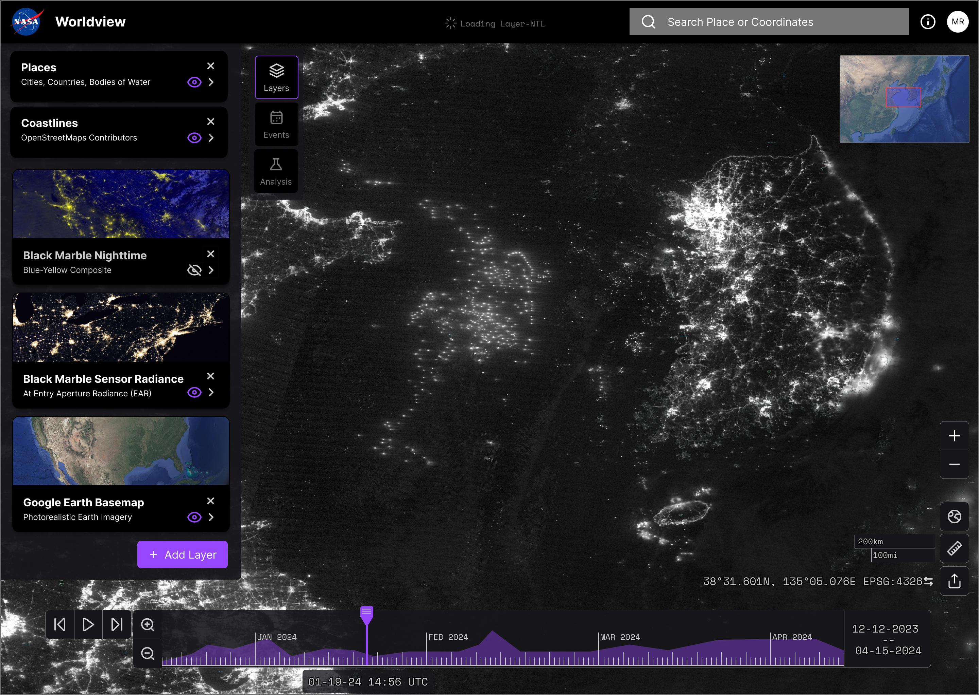

Figure 1: Sample of my prototype. The dashboard provides much more analysis power to the user!

Ideation! : as I continue prototyping the dashboard, it’s now time to think of product interfaces. I love ideation and I facilitate that by performing mind mapping sessions. I particularly set my mind mapping session to be “rapid fire” in pace. By making it short, it really helps me ensure I capture my rawest ideas with no overthinking nor judgment!

My trusty Remarkable Paper Pro tablet is my go-to tool for mind mapping – I like how it’s the tactile writing experience but incredibly rapid to transfer my thoughts to digital storage.

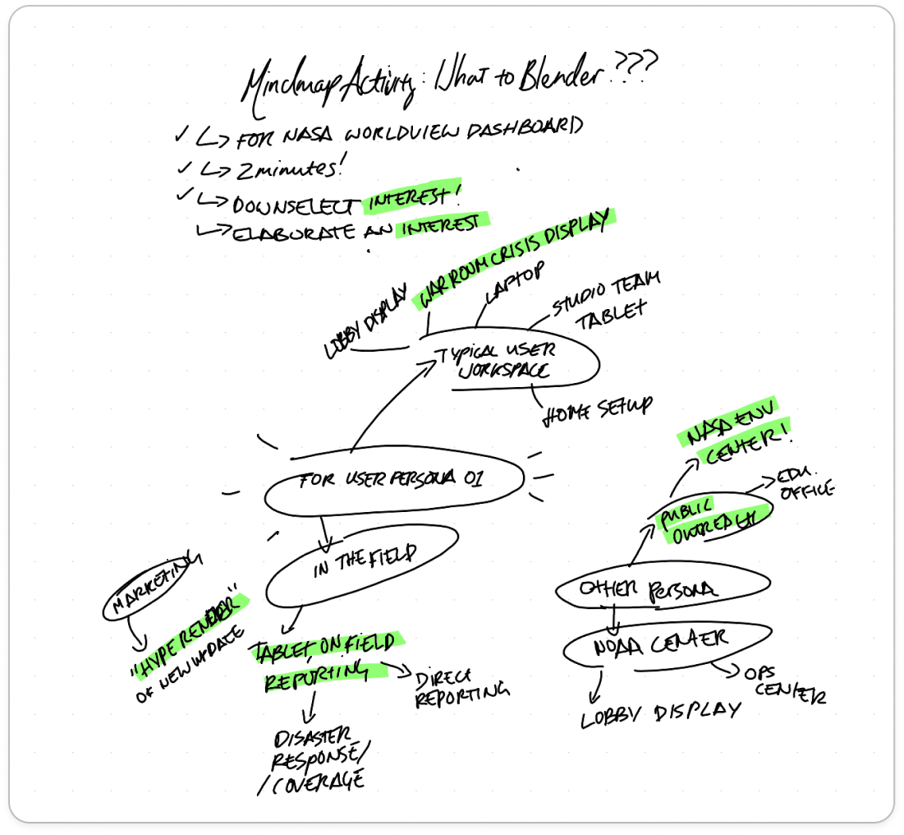

Figure 2: Ideation of What to Blender for my enhanced NASA Worldview Dashboard!

**Pick and Sprint:** From the first mind map, I use my tablet to highlight green key ideas that I want to expand more into as a possible lead. I performed a “sprint” to generate how that idea can become the Blender project:

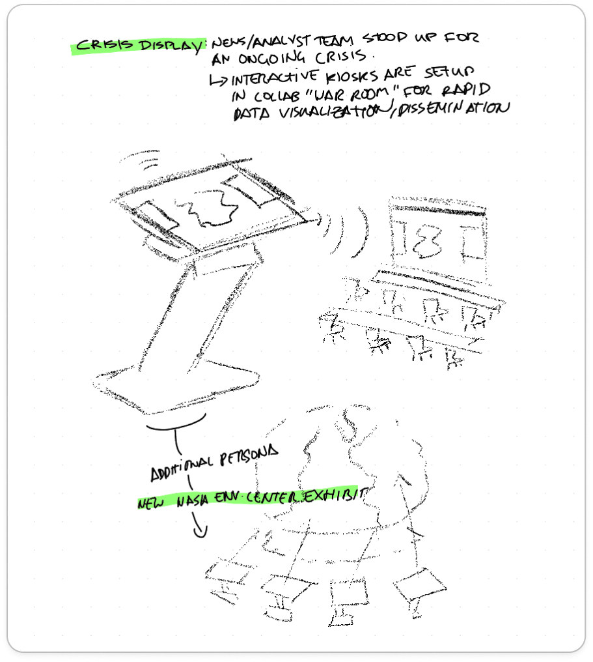

Figure 3: Example idea sprint - maybe use Blender to generate a kiosk that can be used in large conference rooms or at NASA's recently built Environmental Data Center interactive exhibits!

**Liking “Hype Advertisement”:** one of the sprint activities included the idea of creating a marketing ad for the new dashboard updates I’m implementing. My prototype proposes the dashboard to now analysis capabilities now giving users the ability to perform advanced methods on satellite data – this can be a huge ad campaign to draw users!

I collected a couple sample advertisements that came across my social media feeds (coincidence?!) – where the product was a digital interface, but utilize device renders and show features!

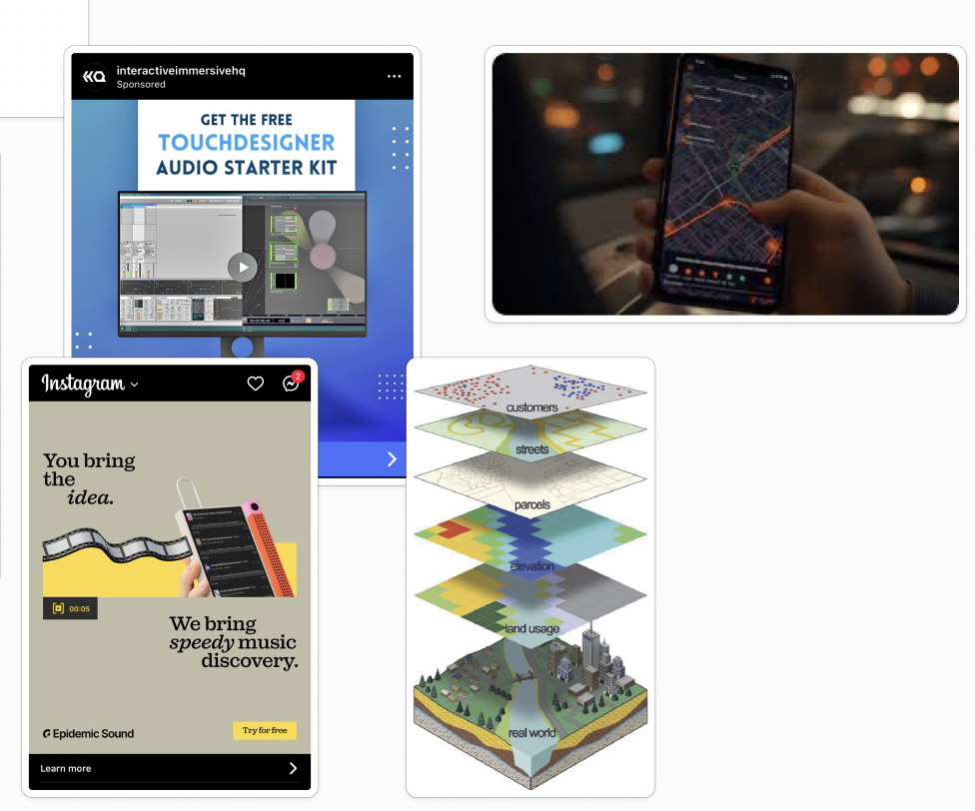

Figure 4: Example ads and visuals!

**Let’s Roll with Futuristic Kiosk! I** decided to go with a Kiosk design because I wanted to think about a hardware that would host the dashboard! I also identified on Blender from a tutorial on how to generate a gradient backdrop – it is very akin to how a photo studio’s backdrop looks like. I gathered reference images along with my sketch to help guide the way. Getting multiple angles of the kiosk really helped me understand the fundamental Blender meshes I will add!

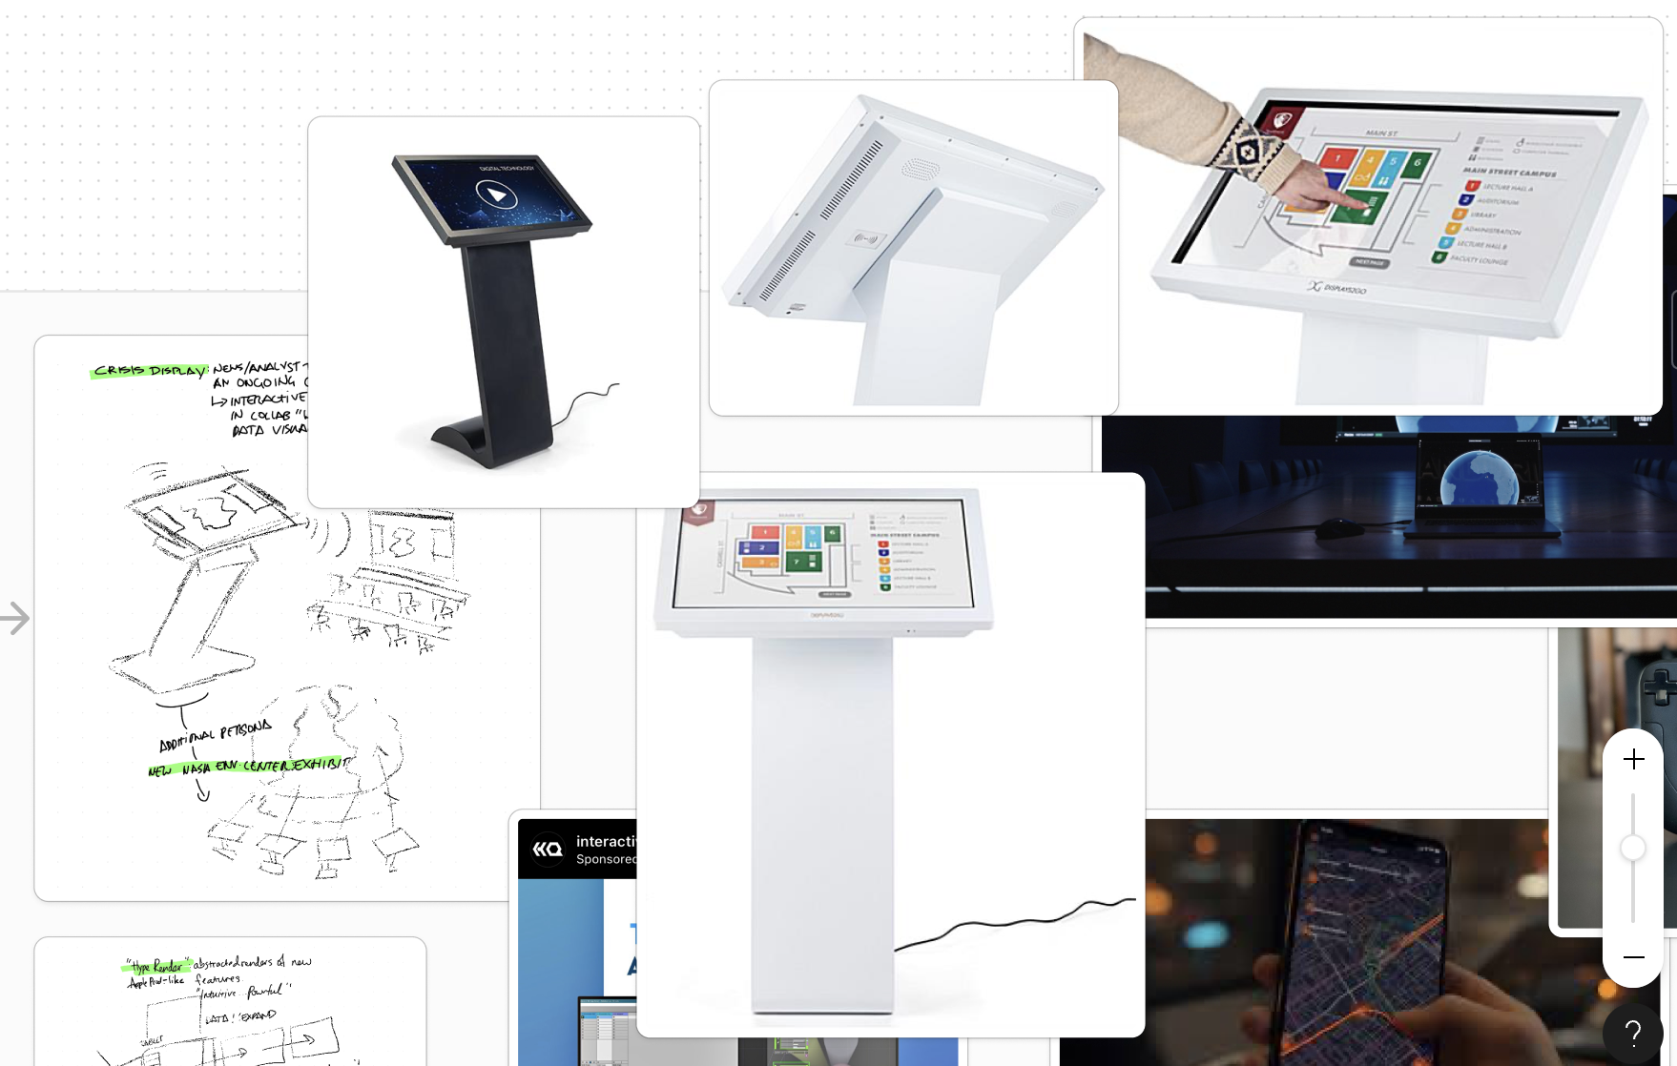

Figure 5: Gathered reference photos of the kiosk. Note the multiple angles that manufacturers conveniently provide!

Determining the screen size:

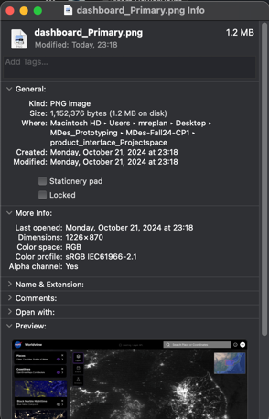

The dashboard PNG is 1226x870. Therefore, the Width is a factor of 1.41x whatever units height is assigned. This will determine the “screen object” of my kiosk.

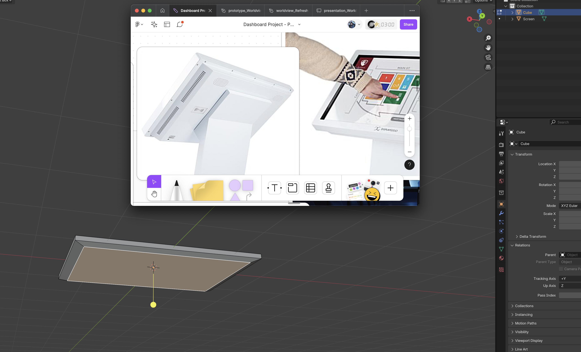

Figure 6: Creating the screen. I made sure to make sure I don't change the screen aspect ratio. I also used bezel tool to create a realistic "backing" of the screen which stores the electronics.

I didn’t really feel the sterile look of the kiosk – it felt more at home at a hospital check in counter. Instead, I looked at more exciting monitor designs and wanted to apply wooden material akin to Samsung “The Frame” TV models:

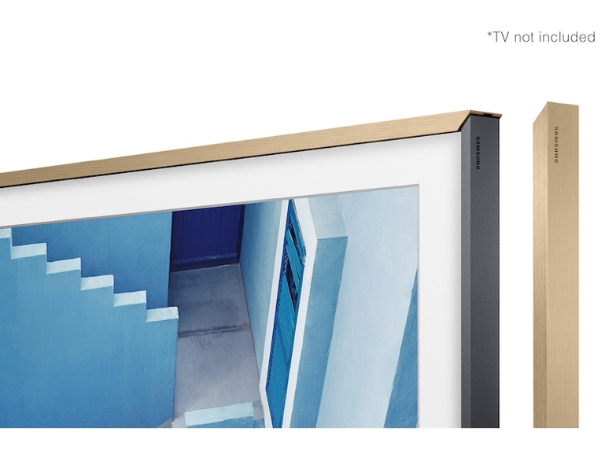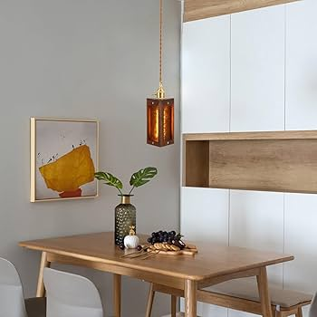

I extended this further with reference photo from my favorite brand, Muji, which uses natural birch combined with off-white metal materials such as the cabinets seen in the photo above.